Deploying Spring Boot application on Kubernetes
Create ec2 instance t2medium/t3medium
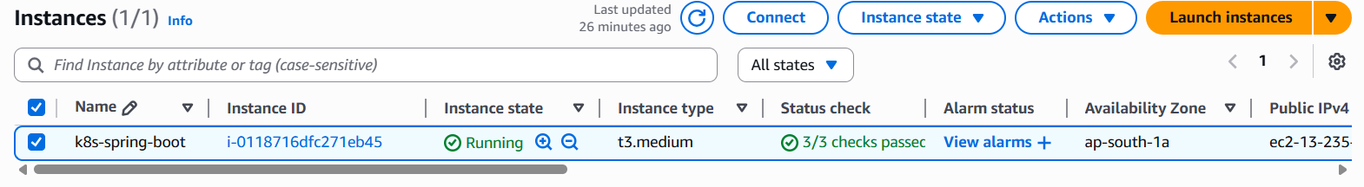
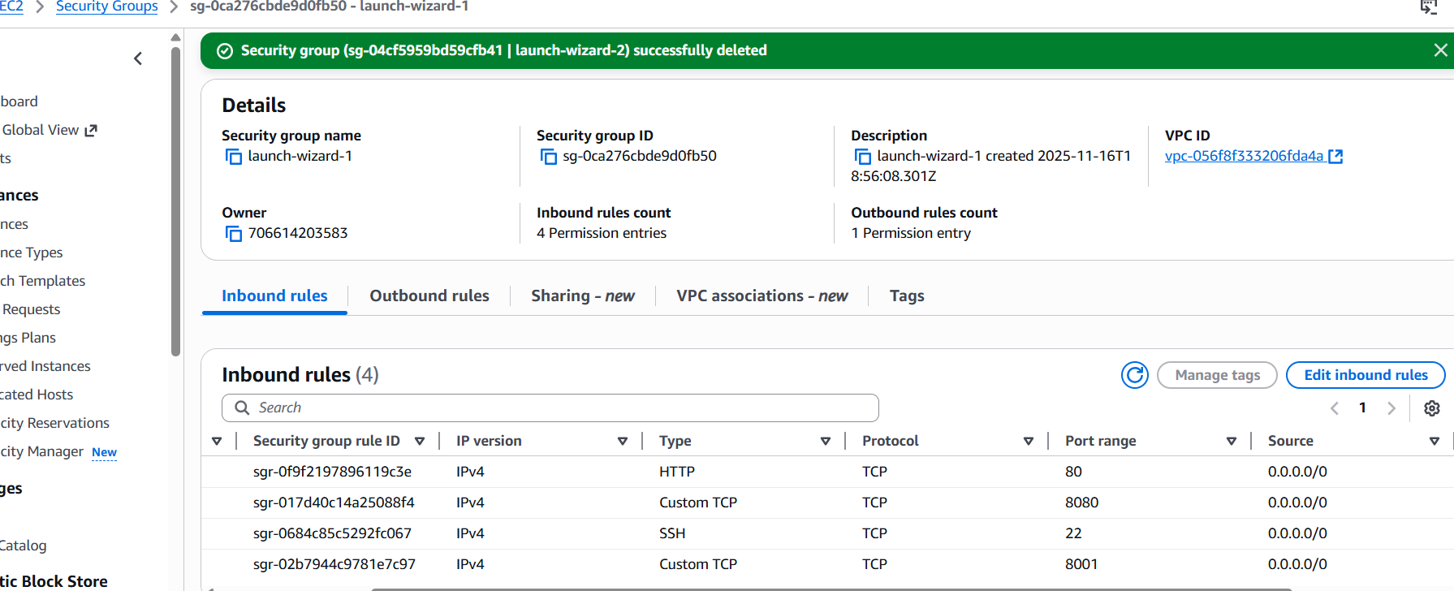

Install Docker on the Instance
Docker is required because Minikube will use Docker as the container runtime
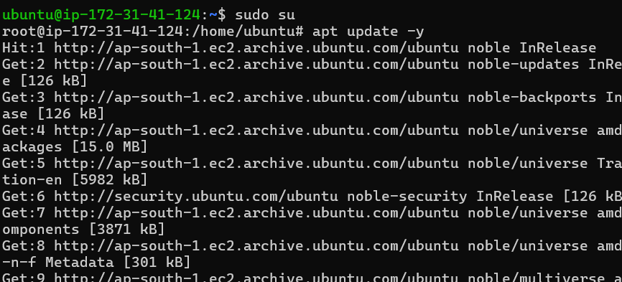
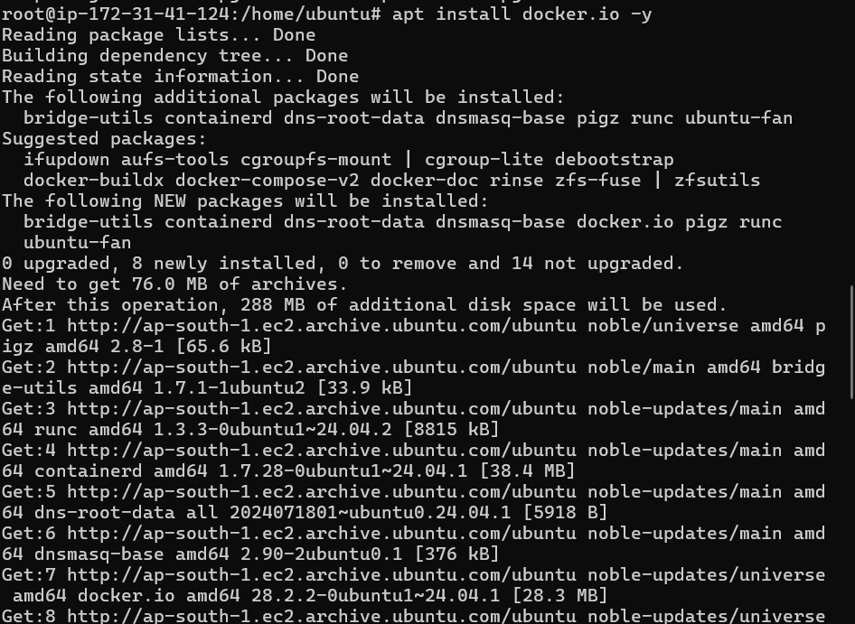

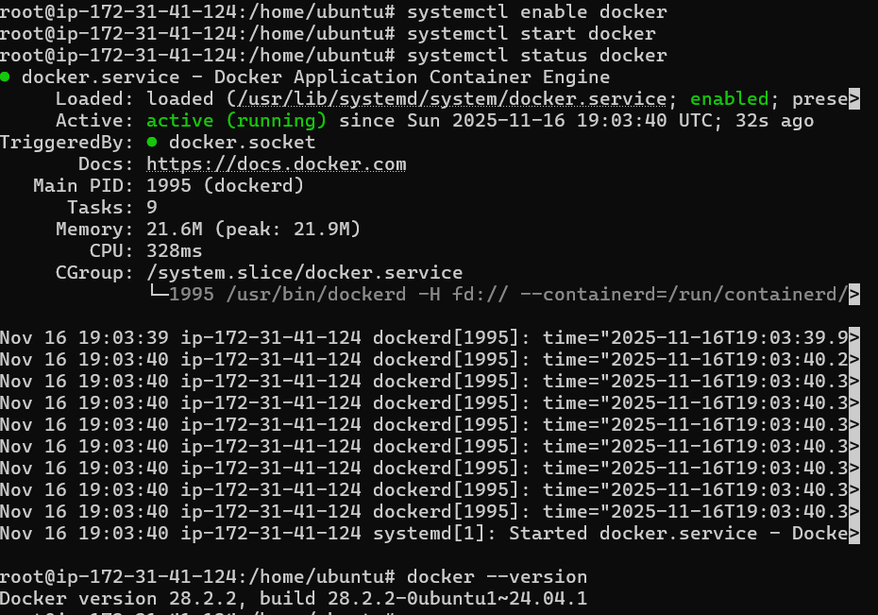

Conntrack helps Kubernetes manage the state of network connections between applications
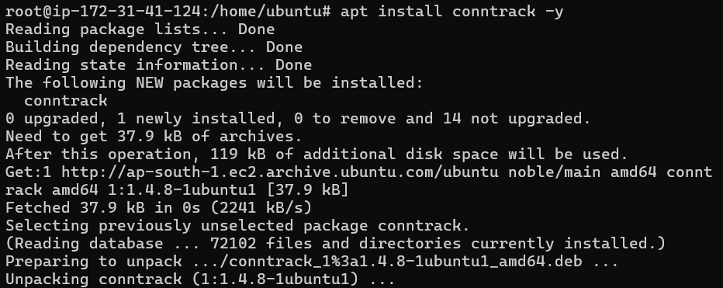

Install and Start Minikube
Minikube creates a local Kubernetes cluster inside your EC2 VM.
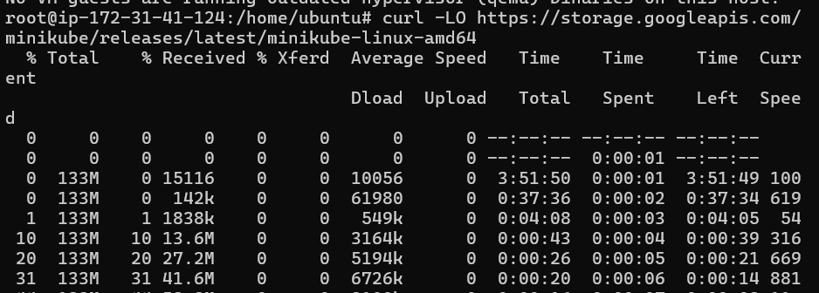
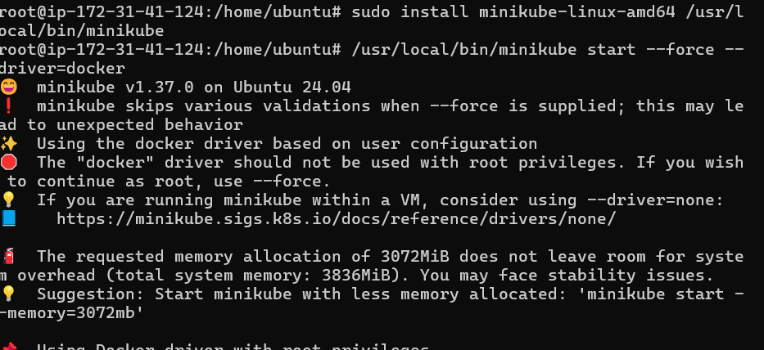

Install kubectl (Kubernetes CLI)
kubectl is used to interact with Kubernetes cluster resources.
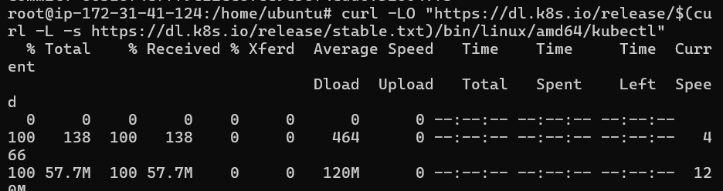
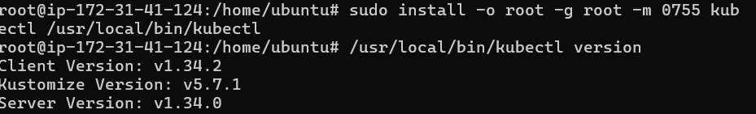

Install Git & Clone Repository
Git is used to download the Spring Boot + K8s project
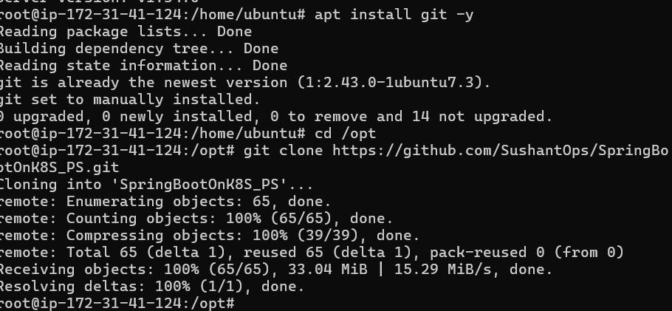

Deploy MySQL Database on Kubernetes
Creates MySQL deployment + persistent volume claim + service.
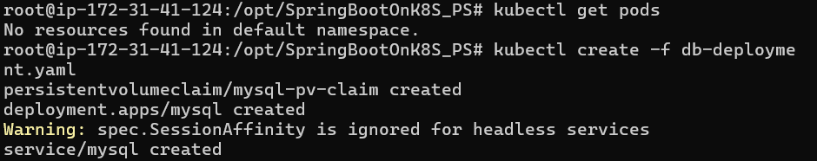
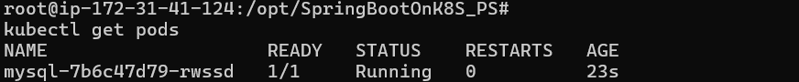

Enter inside MySQL pod
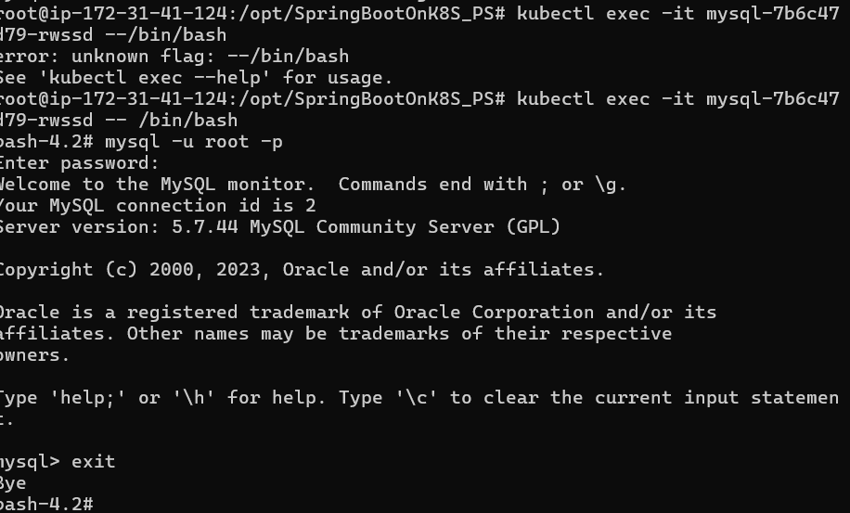

Install Maven
Maven builds Spring Boot jar application.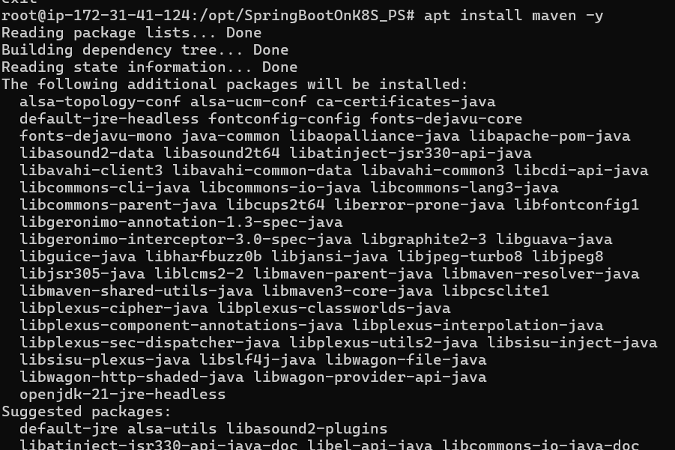
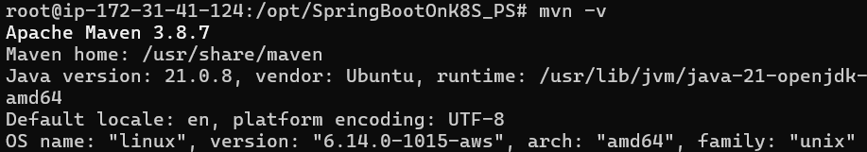

Build Docker Image
Create application Docker image using Dockerfile
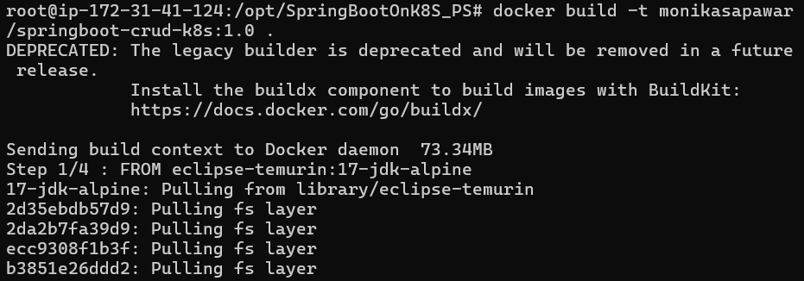
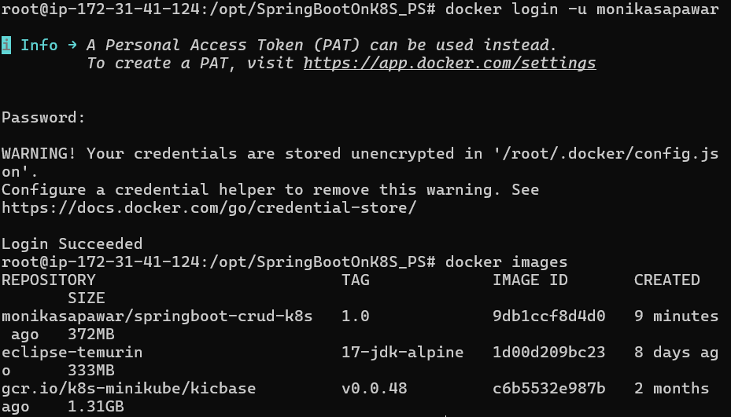
Push Image to DockerHub
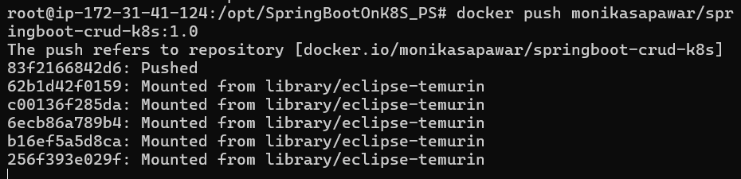

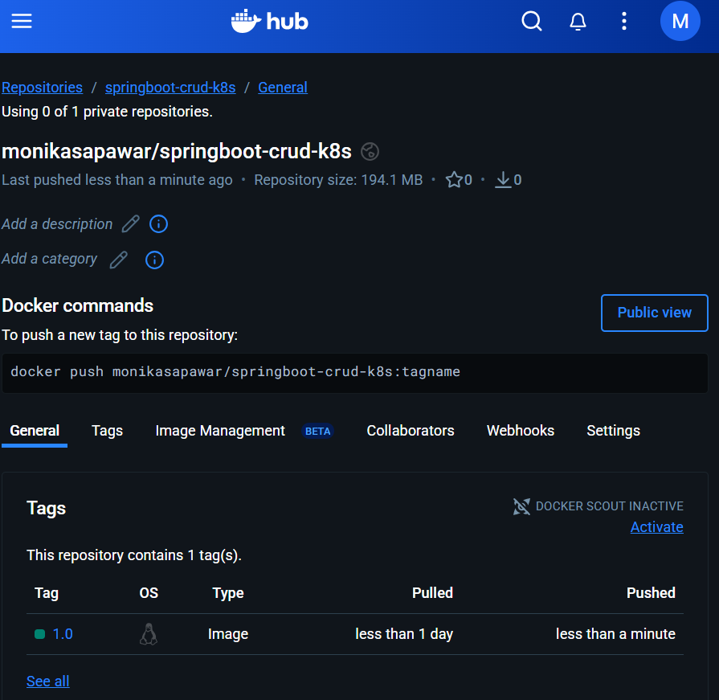
Deploy Spring Boot App on Kubernetes
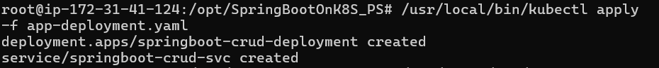

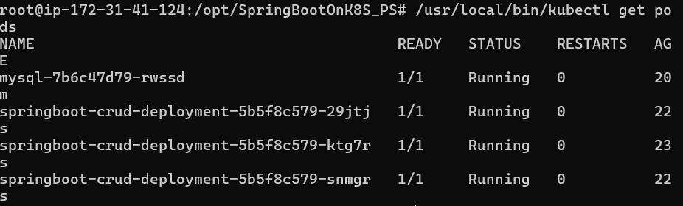
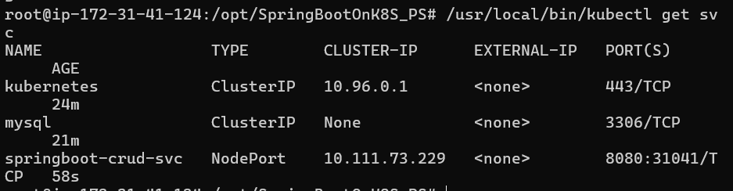

Access Application using Port Forwarding
Port forwarding exposes internal K8s service to external host.
Open Kubernetes Dashboard
Start proxy to expose dashboard outside localhost
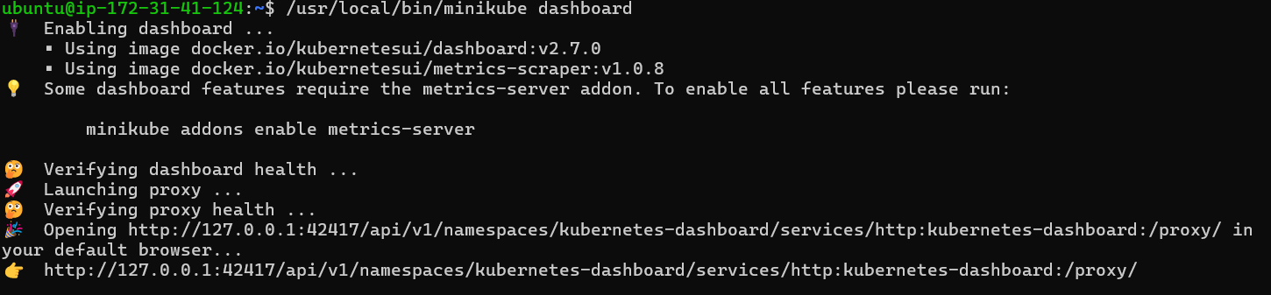
Kubernetes Dashboard using Public IP
http://13.235.115.61:8001/api/v1/namespaces/kubernetes-dashboard/services/http:kubernetes-dashboard:/proxy/#/replicaset?namespace=default
